

AHEC SCHOLARS PROGRAM

Benefits of collaborative practice include:

* Understanding that all health care providers contribute to the team.
* Showing respect and building trust among team members.
* Using appropriate language when speaking to other health care providers.
* Keeping the patient and family at the center of care for the best outcomes.

Join this unique opportunity to learn and practice in a contemporary health care environment.

Gain comprehensive learning experiences that you can include in future job applications and interviews.

Become an ambassador of IPE in current and future health care environments.

Develop IPE Core Competencies: values/ethics, roles/responsibilities, interprofessional communication, teamwork.

Gain valuable clinical experience through additional training opportunities.

**What is Interprofessional Practice and Education (IPE)?**

“Intentional learning when two or more professions learn **about, from, and with** each other to enable effective collaboration and improve health outcomes” (WHO, 2013)

The AHEC Scholars Program is a statewide initiative throughout Georgia. The Magnolia Coastlands AHEC Program is open to students at **Georgia Southern University in the following programs: Nursing, Nutrition, and Public Health (MPH). Students should be entering the final two years of their degree program and be immediately employable in a health care setting**

Students will receive 80 hours of instruction (40 didactic and 40 hands-on clinical experience) during each of the two years of the program.

Requirements of the AHEC Scholars Program come in addition to regular coursework required by your academic program. A stipend will be provided to each student in each year of participation to assist with expenses, travel, food, etc.

Students will be selected through a formal application and must culminate in graduation from a degree program.

BENEFITS

WHY PARTICIPATE

**WHAT IS IPE?**

APPLY TODAY! Deadline 9/20/24

https://magnoliacoastlandsahec.org/ahec-scholars/

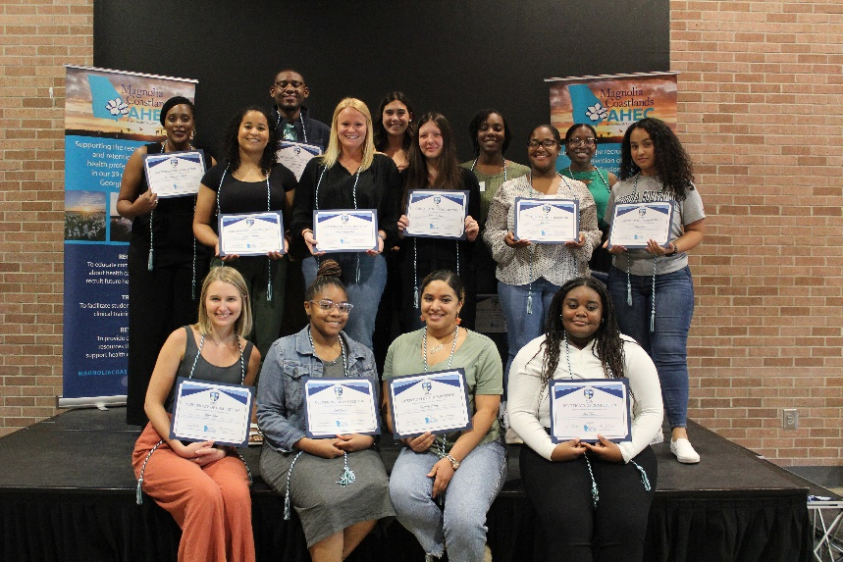

**Interested in applying or need information?**

**Contact Valerie Embry at vembry@georgiasouthern.edu**